CSE 3241 Project

Part 2

Nico Poggio.1

Casey Curran.232

Connor Stevens.1224

Nathan Johnson.9254

1. EER Diagram:

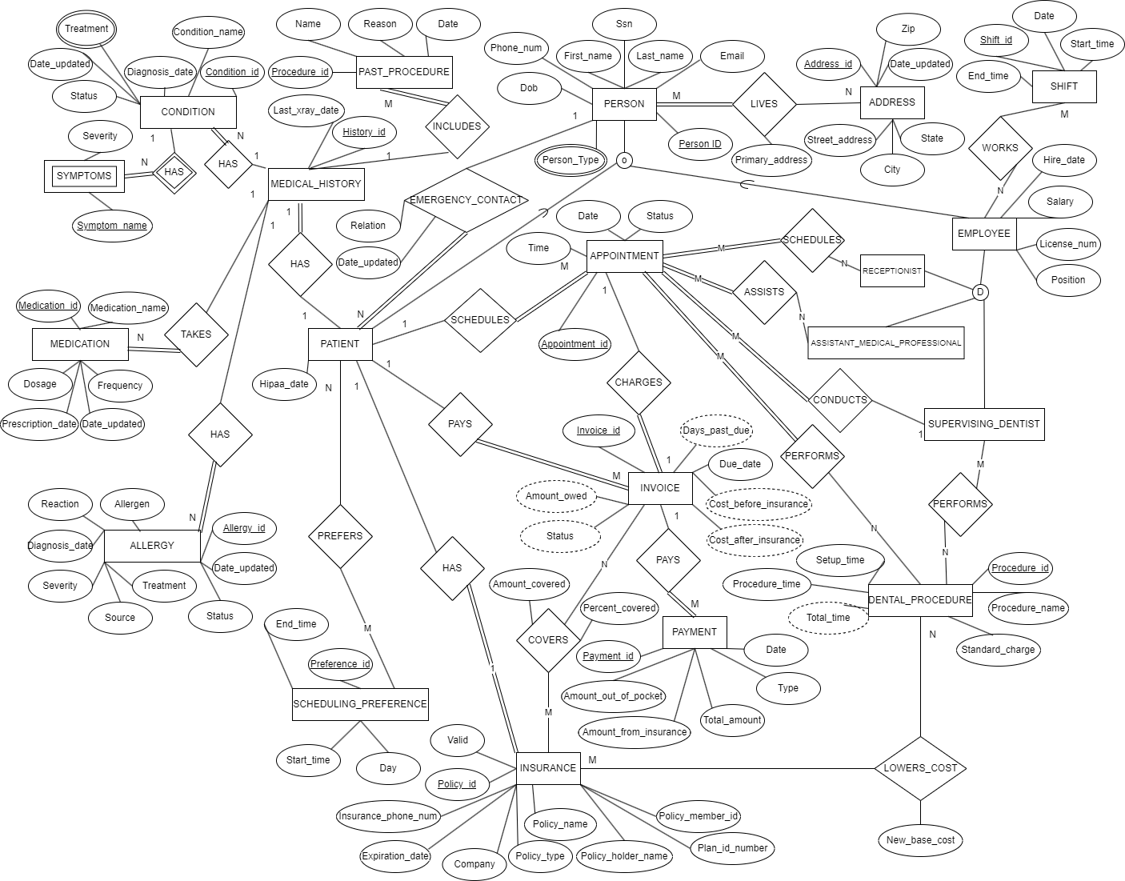

1. **Relational schema**

**Step 1: (Entities)**

PERSON (PersonID, SSN, First_Name, Last_Name, Dob, Phone_num, Email)

SHIFT(Shift_id, Start_time, End_time, Date)

SCHEDULING_PREFERENCE(Preference_id, End_time, Start_time, Day)

PAST_PROCEDURE(Procedure_id, Name, Reason, Date)

MEDICAL_HISTORY(History_id, Last_xray_date)

APPOINTMENT(Appointment_id, Time, Date, Status)

INSURANCE (Policy_id, Company, Plan_id_number, Policy_holder_name, Policy_name, Policy_member_id, Policy_type, Valid, Expiration_date, Insurance_phone_num)

INVOICE (Invoice_id, Due_date)

DENTAL_PROCEDURE(Procedure_id, Setup_time, Procedure_Name, Standard_charge, Procedure_time)

PAYMENT(Payment_id, Total_amount, Amount_out_of_pocket, Amount_from_insurance, Type, Date)

CONDITION(Condition_id, Condition_name, Diagnosis_date, Date_updated, Status)

ADDRESS(Address_id, Zip, Date_updated, Street_address, State, City)

MEDICATION(Medication_id, Medication_name, Dosage, Frequency, Prescription_date, Date_updated)

ALLERGY(Allergy_id, Date_updated, Status, Treatment, Source, Severity, Diagnosis_date, Reaction, Allergen)

**Step 2: (Weak entities)**

SYMPTOMS(Condition_id, Symptom_name, Severity)

Foreign key Condition_id references CONDITION

**Step 3: (1 to N)**

APPOINTMENT (AppointmentID, Time, Date, Status, Patient_id#, Dentist_id#)

Foreign key *Patient_id#* references PERSON

Foreign key *Dentist_id#* references PERSON

INVOICE (InvoiceID, Due_date, Status, *Patient_id#)*

Foreign key *Patient_id#* references PERSON

PAST_PROCEDURE(Procedure_id, Name, Reason, Date, History_id#)

Foreign key *History_id#* references MEDICAL_HISTORY

PAYMENT(Payment_id, Total_amount, Amount_out_of_pocket, Amount_from_insurance, Type, Date, Invoice_id#)

Foreign key *Invoice_id#* references INVOICE

CONDITION(Condition_id, Condition_name, Diagnosis_date, Date_updated, Status, History_id#)

Foreign key *History_id#* references MEDICAL_HISTORY

MEDICATION(Medication_id, Medication_name, Dosage, Frequency, Prescription_date, Date_updated, History_id#)

Foreign key *History_id#* references MEDICAL_HISTORY

ALLERGY(Allergy_id, Date_updated, Status, Treatment, Source, Severity, Diagnosis_date, Reaction, Allergen, History_id#)

Foreign key *History_id#* references MEDICAL_HISTORY

**Step 4: (1 to 1)**

INVOICE(Invoice_id, Due_date, Status, *Appointment_id#*, *Patient_id#*)

Foreign key *Appointment_id#* references APPOINTMENT

Foreign key *Patient_id#* references PERSON

MEDICAL_HISTORY (History_ID, Last_XRay_Date, Patient_id#)

Foreign key Patient_id# references PERSON

INSURANCE (Policy_ID, Valid, Insurance_Phone_Num, Expiration_date, Company, Policy_type, Policy_holder_name, Policy_member_ID, *PatientID#*)

Foreign key *Patient_id#* references PERSON

**Step 5: (N to M)**

APPOINTMENT_RECEPTIONIST(Appointment_id#, Receptionist_id#)

Foreign key Appointment_id# references APPOINTMENT

Foreign key Receiptionist_id# references PERSON

APPOINTMENT_ASSISTANT(Appointment_id#, Assistant_id#)

Foreign key Appointment_id# references APPOINTMENT

Foreign key Assitant_id# references PERSON

APPOINTMENT_PROCEDURE(Appoint_id#, Proc_id#)

Foreign key Appoint_id# references APPOINTMENT

Foreign key Proc_id# references DENTAL_PROCEDURE

PROCEDURE_DENTIST(Med_Procedure_id#, Denist_id#)

Foreign key Med_Procedure_id# references DENTAL_PROCEDURE

Foreign key Dentist_id# references PERSON

COVERING_INSURANCE(Policy_id#, Invoice_id#, Amount_covered, Percent_covered)

Foreign key Policy_id# references INSURANCE

Foreign key Invoice_id# references INVOICE

PATIENT_PREFERENCE(Preference_id#, Patient_id#)

Foreign key Preference_id# references SCHEDULING_PREFERENCE

Foreign key Patient_id# references PERSON

EMPLOYEE_SHIFT(Shift_id#, Employee_id#)

Foreign key Shift_id# references SHIFT

Foreign key Employee_id# references PERSON

PERSON_ADDRESS(Person_id#, Address_id#, Primary_address)

Foreign key Person_id# references PERSON

Foreign key Address_id# references ADDRESS

PROCEDURE_DENTIST(Person_id#, Procedure_id#)

Foreign key Person_id# references PERSON

Foreign key Procedure_id# references PROCEDURE

INSURANCE_PROCEDURE(Policy_id#, Proc_id#)

Foreign Key Policy_id# references INSURANCE

Foreign key Proc_id# references DENTAL_PROCEDURE`

**Step 6: (Multivalued Attributes)**

TREATMENT(Condition_id#, Treatment)

Foreign key Condition_id# references CONDITION

PERSON_TYPE (Person_id#, PersonType)

Foreign key Person_id# references PERSON

**Step 7: (n-ary relationships)**

**No n-ary relationships**

**Step 8: (Specializations)**

PERSON (Person_id, SSN, First_Name, Last_Name, Dob, Phone_num, Email, Hipaa_date, Hire_date, Salary, License_num, Position, Contact_id#, Relation, Date_updated)

Foreign key Contact_id# references PERSON

Receptionist(Person_id)

Foreign key Person_id references PERSON

Assistant_Medical_Professional(Person_id)

Foreign key Person_id references PERSON

Supervising_Dentist(Person_id)

Foreign key Person_id references PERSON

**Step 9: (Union types)**

No unions

**Final Relational Schema:**

PERSON (Person_id, SSN, First_name, Last_name, Dob, Phone_num, Email, Hipaa_date, Hire_date, Salary, License_num, Position, Contact_id#, Relation, Date_updated)

Foreign key Contact_id# references PERSON

SHIFT(Shift_id, Start_time, End_time, Date)

SCHEDULING_PREFERENCE(Preference_id, End_time, Start_time, Day)

PAST_PROCEDURE(Procedure_id, Name, Reason, Date, History_id#)

Foreign key *History_id#* references MEDICAL_HISTORY

MEDICAL_HISTORY (History_ID, Last_XRay_Date, Patient_id#)

Foreign key Patient_id# references PERSON

APPOINTMENT (AppointmentID, Time, Date, Status, Patient_id#, Dentist_id#)

Foreign key *Patient_id#* references PERSON

Foreign key *Dentist_id#* references PERSON

INSURANCE (Policy_ID, Valid, Insurance_phone_num, Expiration_date, Company, Policy_type, Policy_holder_name, Policy_member_id, Plan_id_number, *PatientID#*)

Foreign key *Patient_id#* references PERSON

INVOICE(Invoice_id, Due_date, Status, *Appointment_id#*, *Patient_id#*)

Foreign key *Appointment_id#* references APPOINTMENT

Foreign key *Patient_id#* references PERSON

DENTAL_PROCEDURE(Procedure_id, Setup_time, Procedure_Name, Standard_charge, Procedure_time)

PAYMENT(Payment_id, Date, Total_amount, Amount_out_of_pocket, Amount_from_insurance, Type, Date, Invoice_id#)

Foreign key *Invoice_id#* references INVOICE

CONDITION(Condition_id, Condition_name, Diagnosis_date, Date_updated, Status, History_id#)

Foreign key *History_id#* references MEDICAL_HISTORY

ADDRESS(Address_id, Zip, Date_updated, Street_address, State, City)

MEDICATION(Medication_id, Medication_name, Dosage, Frequency, Prescription_date, Date_updated, History_id#)

Foreign key *History_id#* references MEDICAL_HISTORY

ALLERGY(Allergy_id, Date_updated, Status, Treatment, Source, Severity, Diagnosis_date, Reaction, Allergen, History_id#)

Foreign key *History_id#* references MEDICAL_HISTORY

APPOINTMENT_RECEPTIONIST(Appointment_id#, Receptionist_id#)

Foreign key Appointment_id# references APPOINTMENT

Foreign key Receiptionist_id# references PERSON

SYMPTOMS(Condition_id, Symptom_name, Severity)

Foreign key Condition_id references CONDITION

APPOINTMENT_ASSISTANT(Appointment_id#, Assistant_id#)

Foreign key Appointment_id# references APPOINTMENT

Foreign key Assitant_id# references PERSON

APPOINTMENT_PROCEDURE(Appoint_id#, Proc_id#)

Foreign key Appoint_id# references APPOINTMENT

Foreign key Proc_id# references DENTAL_PROCEDURE

PROCEDURE_DENTIST(Med_Procedure_id#, Denist_id#)

Foreign key Med_Procedure_id# references DENTAL_PROCEDURE

Foreign key Dentist_id# references PERSON

COVERING_INSURANCE(Policy_id#, Invoice_id#, Amount_covered, Percent_covered)

Foreign key Policy_id# references INSURANCE

Foreign key Invoice_id# references INVOICE

PATIENT_PREFERENCE(Preference_id#, Patient_id#)

Foreign key Preference_id# references SCHEDULING_PREFERENCE

Foreign key Patient_id# references PERSON

EMPLOYEE_SHIFT(Shift_id#, Employee_id#)

Foreign key Shift_id# references SHIFT

Foreign key Employee_id# references PERSON

PERSON_ADDRESS(Person_id#, Address_id#, Primary_address)

Foreign key Person_id# references PERSON

Foreign key Address_id# references ADDRESS

TREATMENT(Condition_id#, Treatment)

Foreign key Condition_id# references CONDITION

PERSON_TYPE (Person_id#, PersonType)

Foreign key Person_id# references PERSON

RECEPTIONIST(Person_id#)

Foreign key Person_id references PERSON

ASSISTANT_MEDICAL_PROFESSIONAL (Person_id#)

Foreign key Person_id references PERSON

SUPERVISING_DENTIST(Person_id#)

Foreign key Person_id references PERSON

3. Relational Algebra

1. Create a list of patients and the medications they currently take

π First_name, Last_name, Medication_name (σPersonType = “Patient”  (PERSON ⨝ Person_id = Person_id# PERSON_TYPE ⨝ Person_id = Patient_id# MEDICATION_HISTORY ⨝ History_ID = History_id# MEDICATION))

1. Display patient information for patients who currently have Delta Dental insurance policy.

π SSN, First_name, Last_name, Dob, Phone_num, Email, Hipaa_date (σCompany = “Delta Dental” (σPersonType = “Patient”  (PERSON ⨝ Person_id = Person_id# PERSON_TYPE ⨝ Person_id = PatientID# INSURANCE)))

1. Generate a list of procedures and dates of service performed by doctor Smilow.

π ProcedureName, Date (σ Last_Name = “Smilow”(PERSON ⨝ Person_id = Person_id# SUPERVISING_DENTIST ⨝ Person_id = Dentist_ID# PROCEDURE_DENTIST ⨝ Med_Procedure_id = ProcedureID# DENTAL_PROCEDURE ⨝ ProcedureID = ProcID# APPOINTMENT_PROCECURE ⨝ Appoint_id# = AppointmentID# APPOINTMENT))

1. Print out a list of past due invoices with patient contact information. Past due is defined as over 30 days old with a balance over $10.

π DueDate, Status, FirstName, LastName, Phone_num, Email (σDays_Past_Due > 30 AND Amount_Owed > 10(PERSON ⨝ Person_id = Person_id# PERSON_TYPE ⨝ Person_id = Person_id# INVOICE ))

1. Find the patients who brought the most revenue in the past year.

PATIENT_SUMS ← Person_idFSUM Amount (σPersonType = “Patient” (PERSON ⨝Person_id = Person_id# PERSON_TYPE ⨝Person_id# = Patient_id# INVOICE ⨝ Invoice_id = Invoice_id# PAYMENT))

AVERAGE_SUM ← FAVERAGE Amount(PATIENT_SUMS)

σSUM_Amount > AVERAGE_SUM_Average_Amount(PATIENT_SUMS)

1. Create a list of doctors who performed less than 5 procedures this year.

RESULT ← DentistID F COUNT ProcedureID (PROCEDURE_DENTIST)

σ COUNT(ProcedureID) < 5 (RESULT)

1. Find the highest paying procedures, procedure price, and the total number of those procedures performed.

MAX_RESULT ← Procedure_idFMAX Standard_charge(DENTAL_PROCEDURE)

SECOND_MAX ← Procedure_idFMAX Standard_charge(σ ProcedureID < MAX_RESULT_Standard_charge(DENTAL_PROCEDURE))

RESULT ← Procedure_name, Standard_chargeFCOUNT Appointment_id((σProcedure_id = MAX_RESULT_Procedure_id(DENTAL_PROCEDURE)) ∪ (σProcedure_id = SECOND_MAX_Procedure_id(DENTAL_PROCEDURE)) ⟕ProcID = Procedure_id(APPOINTMENT_PROCEDURE)))

1. Create a list of all payment types accepted, number of times each of them was used, and total amount charged to that type of payment

TypeFCOUNT Payment_id, SUM Amount(PAYMENT)

1. List ids and names of insurance plans ever used by patients and how many patients have that plan.

Policy_id, Policy_nameFCOUNT Person_id(INSURANCE)

4. Additional queries:

1. Outer join

List of patients where the due date of their invoice is on the same day as their appointment.

PERSON ⟕Person_id = Patient_id#(σDue_Date == Date(INVOICE⨝Appointment_id# = Appointment_idAPPOINTMENT))

1. Aggregate function

Procedure with the shortest time.

NameFMin Procedure_Time(DENTAL_PROCEDURE)

1. Extra entities

Scheduling preference is inside of an available shift time

σStart_Time >= Start_Time AND End_Time <= End_Time(SCHEDULING_PREFERENCE ⟗ Day = DateSHIFT)

5. Specification Sheets

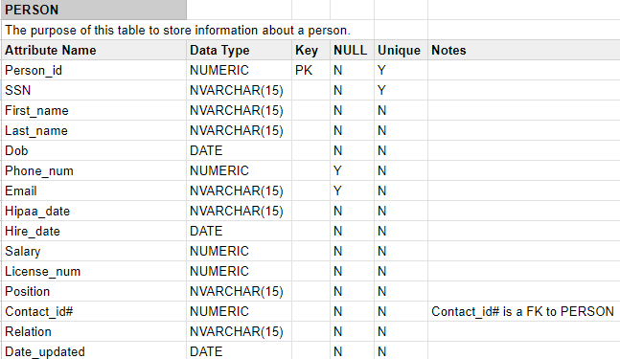

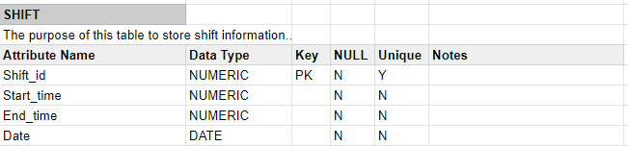

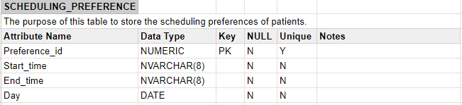

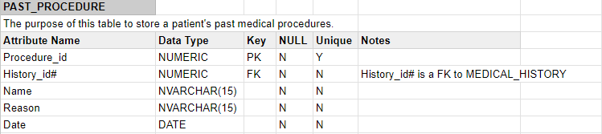

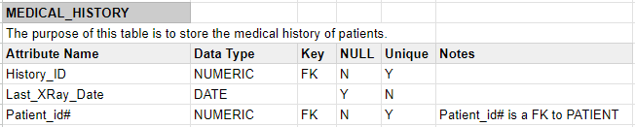

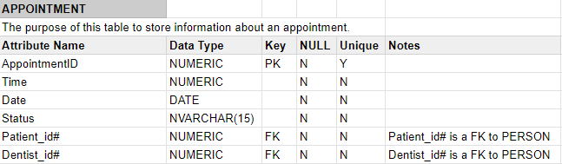

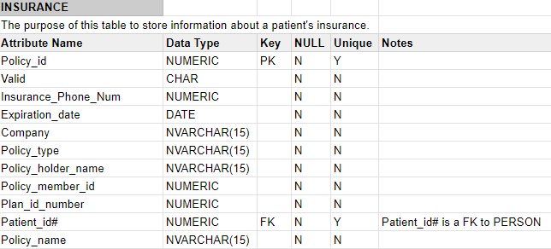

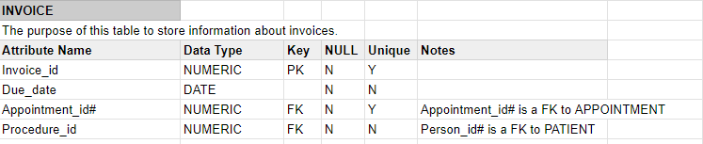

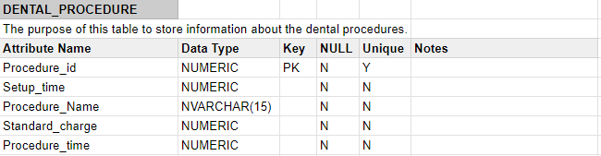

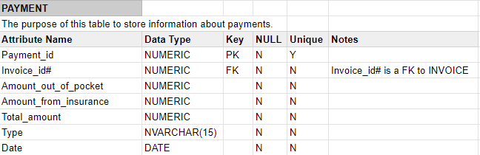

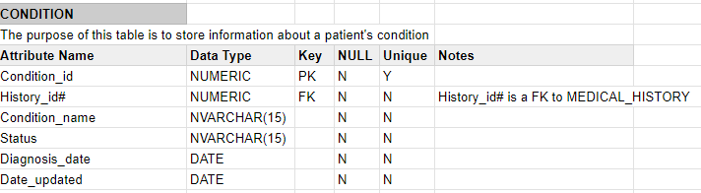

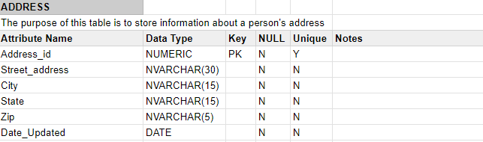

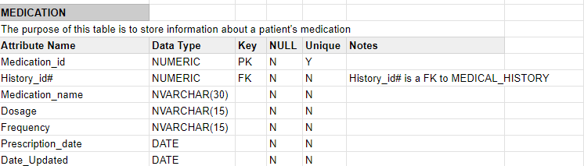

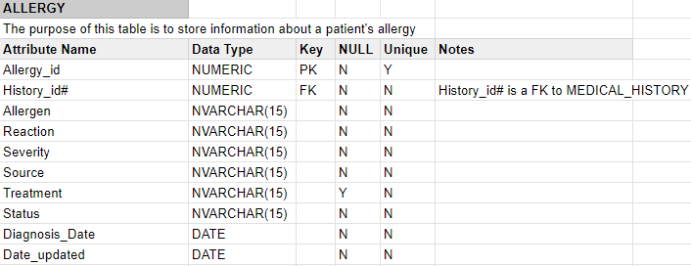

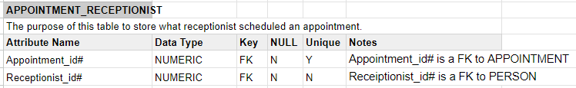

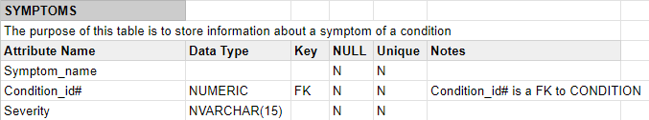

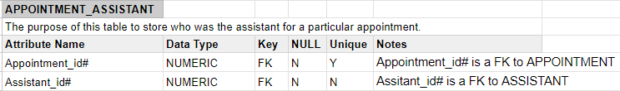

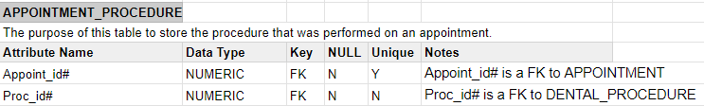

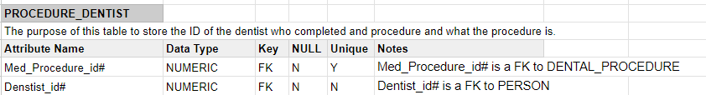

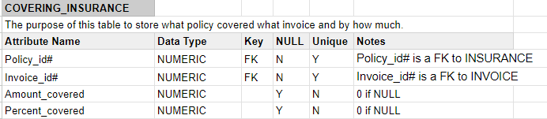

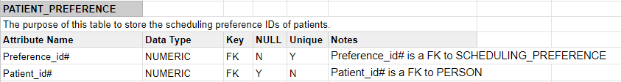

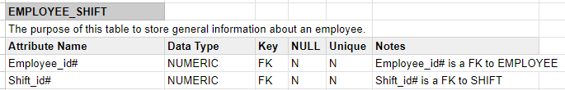

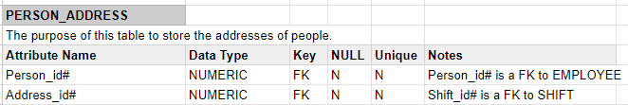

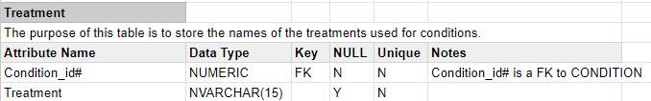

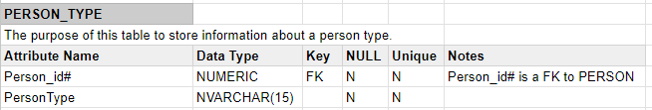

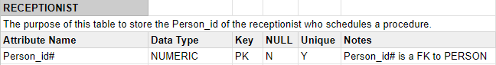

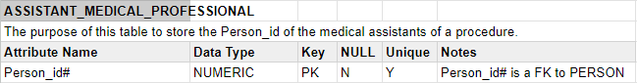

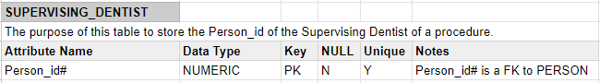

6. Original ERD and comments

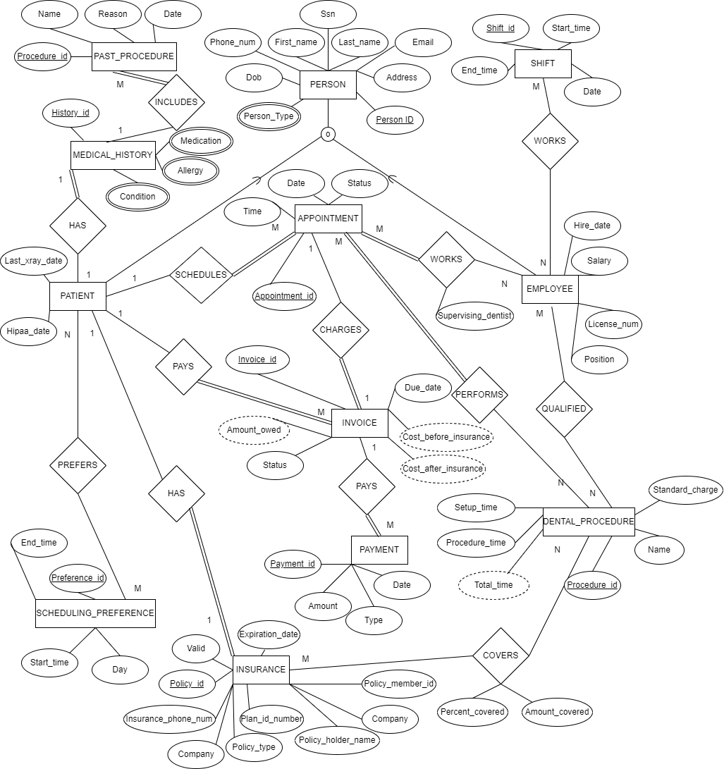

Comments we received:

-PATIENT and EMPLOYEE are overlapping. We mistakenly listed it as disjoint under entities and relationships.

-EMPLOYEE entity should have specialization entities.

Added RECEPTIONIST, ASSISTANT_MEDICAL_PROFESSIONAL, and SUPERVISING_DENTIST specializations

-DENTAL_PROCEDURE could be charged differently based on different policy types

Added the LOWERS_COST relationship between INSURANCE and DENTAL_PROCEDURE, so that the base cost for each operation can change according to policy.

-PAYMENT can be split up between INSURANCE and PATIENT

For PAYMENT, replaced the Amount attribute with two attributes: Amount_out_of_pocket and Amount_from_insurance

Team Member Contributions:

Nico Poggio.1: Worked on the first draft of the relational schema. Created and adjusted the relational algebra queries.

Casey Curran.232: Worked on building on relational schema, worked on relational algebra queries, worked on additional queries, built out specification sheets, helped with ERD changes

Connor Stevens.1224: Revised the EERD according to the feedback from part 1. Updated the relational schema and specification sheet to reflect these changes. Helped with relational algebra.

Nathan Johnson.9254: Created some of the entities in #2 from steps 1-9. Created first draft of #4 answers. Created ~100 tables in the first version of the specification sheet.

As a team, we were able to effectively communicate using Discord and setting up specific times to meet and do work. As individuals, we would split up and delegate what we were working on. However, we could always text each other with any questions/concerns while we worked through the project if anything came up while we were not on a call.